and Moravian Library

would like to invite you to a workshop

MAKING ROLEPLAY, IMPROVISATION AND PLAYS YOUR CLASSMATE
From the moment we leave the house we play different roles throughout our day. Drama is an intrinsic part of life. And yet, sadly, drama is generally absent from the classroom.
In the classroom, role play and dialogues in course books often feel disengaging, shallow and impersonal. This workshop will reveal how to get the most out of role play, improvisation as well as actual plays to teach every aspect of English – enriching and rejuvenating the classroom with little or no preparation. Teaching grammar, vocabulary and pronunciation through drama livens up a course book effortlessly. Learning will never feel so joyful and authentic!
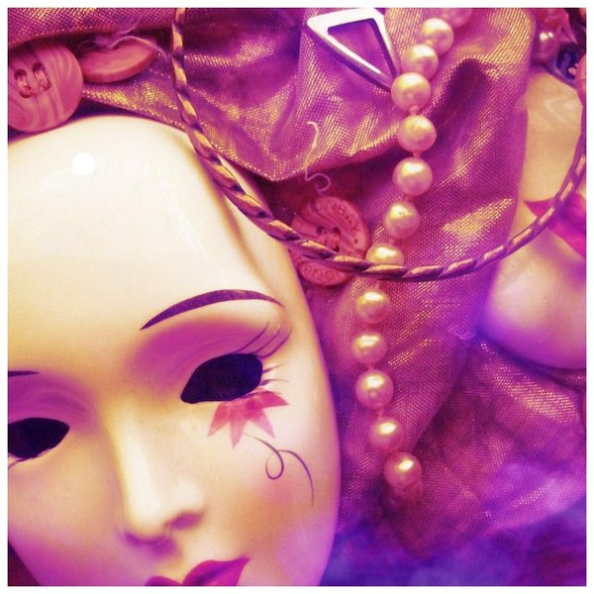

Date: 12 December 2013
Time: 1PM – 4PM
Place: Moravska zemska knihovna
Kounicova 65a
601 87 Brno
Registration fee: 200 CZK
To request a place at the seminar please register online on our website British Council.

Jat Dhillon works at the British Council, Charles University and Lycee Francais de Prague. He gives special teacher training workshops that are designed to be a very practical, fun and dramatic way of livening up the classroom. He is the founder of 2 English drama companies – The Drama Queens at Charles University and The Young Drama Queens at Lycee Francais de Prague. He has directed Havel’s The Beggar’s Opera, and Redevelopment and Goldoni’s A Servant to Two Masters Michael Frayn’s Noises Off. He is also travelling around the Czech Republic sharing a new, invigorating approach to teaching English through drama. This year he is directing a musical.

